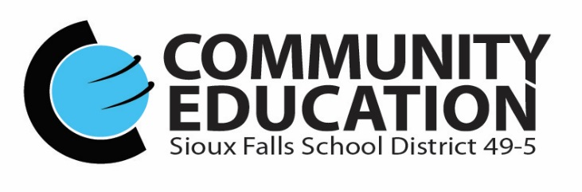

Dear Community Education Partner Instructors;

We are excited to have our Spring & Summer 2017 Community Education catalog off to the printer and hitting mailboxes and streets in mid-January! Of course, it is never too early to begin working on new classes and new partnerships for the Fall & Winter 2017 lineup!

Our goal is to offer the community a great lineup of class opportunities to our community members - young and old! Through our partnerships with excellent instructors, we have the opportunity to offer a boundless spectrum of classes!

Our catalogs are directly mailed to over 64,000 residents and businesses in mid-January and mid-August, with 2000 more spread throughout the community. Our objective is for students, our partner instructors, and our staff to have positive learning experiences and opportunities!

To view our current catalog, please go to
http://www.sf.k12.sd.us/our-district/community-education

We are happy to assist with titles and description to entice students to your classes. An outline of the information to submit class is below.

We will send out instructor partnership invitations towards the end of March to officially start the coordination of the next catalog. This catalog will cover classes from the September to December 2017.

Thank you so much for your interest and we look forward to discussing partnerships with you!

Sincerely;

Melodee R. Kloiber Kelli Fahey
Community Education - Adult Community Education - Youth
(605) 367-7606 (605) 367-4384
Melodee.kloiber@k12.sd.us kelli.fahey@k12.sd.us

This form is not required. Emailed information is preferred so we can just copy & paste into our class registration software!

SFSD Community Education Class

Instructor Contact Info – (name, address, phone, email)

Title & Description (innovative, appealing)

Date(s) / Times (Wednesday classes end by 6:30 p.m. No classes on Saturday or Sunday. If using district facilities for classes- please end by 8:30 p.m.)

Location

Maximum # of Students

Material Fees (to be paid directly to instructor)

Equipment needed if using our classrooms – (access to websites - please list, laptop computer, smartboard, dry erase board & markers)

Instructor Marketing and/or ideas for Community Education Marketing

Picture of you doing your thing, a head shot or a family pic & Biography – (your background and why you are interested in Community Education) Students can click on your name online and it will take them to your bio and picture.

